Computer

Web development

My website

By yehia Islam

Using VScode Editor

Website Idea

It is a website that shows all my projects in different coding languages

Languages used

HTML, HTML5, JavaScript, CSS, Bootstrap 4 & 5

So, what you can find in my website

First page / index.html

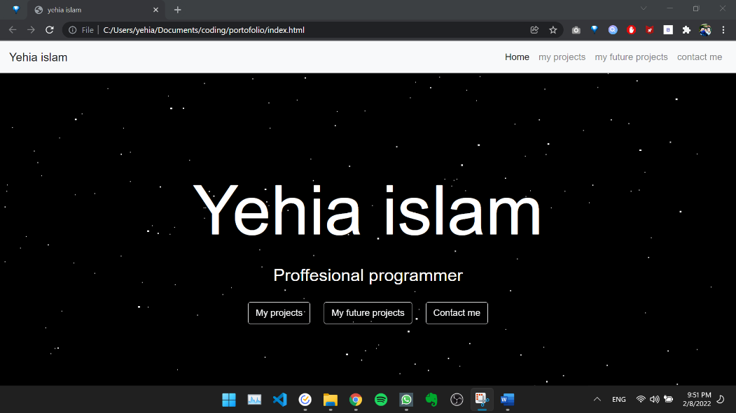

Firstly:

You can see navigation bar that links all web pages with each other.

Secondly:

You can see the background color is black and that dots moves and coded in CSS

Thirdly:

You can see 3 button that will change their color once you drag your mouse on and these buttons link to other web pages

Second page / my project.html



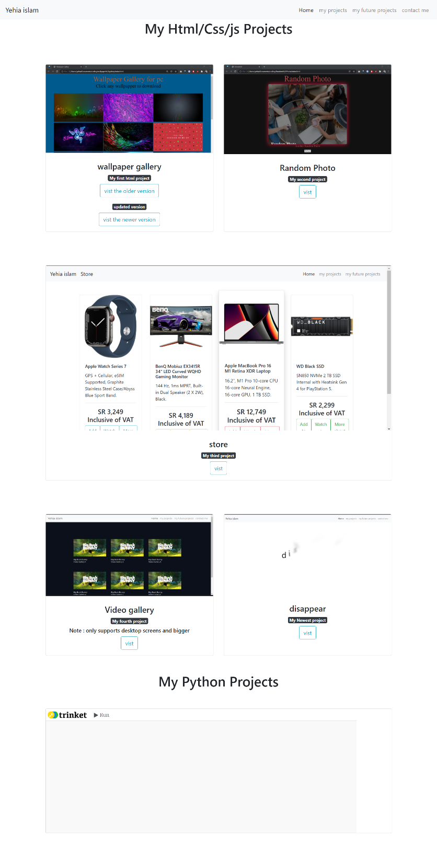

Firstly:

To access this page will be by the navigation bar or from my project button in main page.

Secondly:

Here you got all my projects I have done.

Thirdly:

By dragging your mouse over any of these cards a hover effect will happen.

Fourthly:

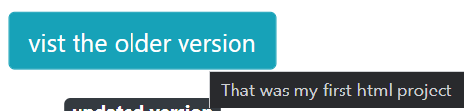By dragging your mouse over any of the buttons there color will change and tooltip effect will happen:

Fifthly:

Every button in these cards is linked to that project with the navigation bar.

Third page / My Future projects .html



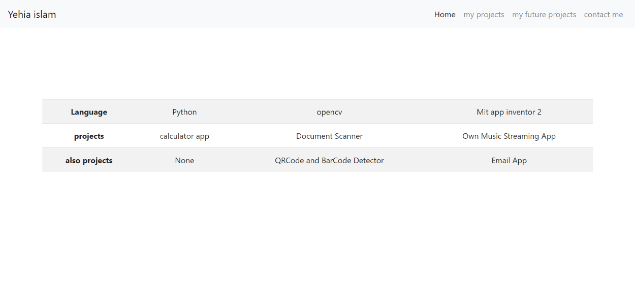Firstly:

A simple table discussing project I am willing to do

Fourth page / Contact me .html



Firstly:

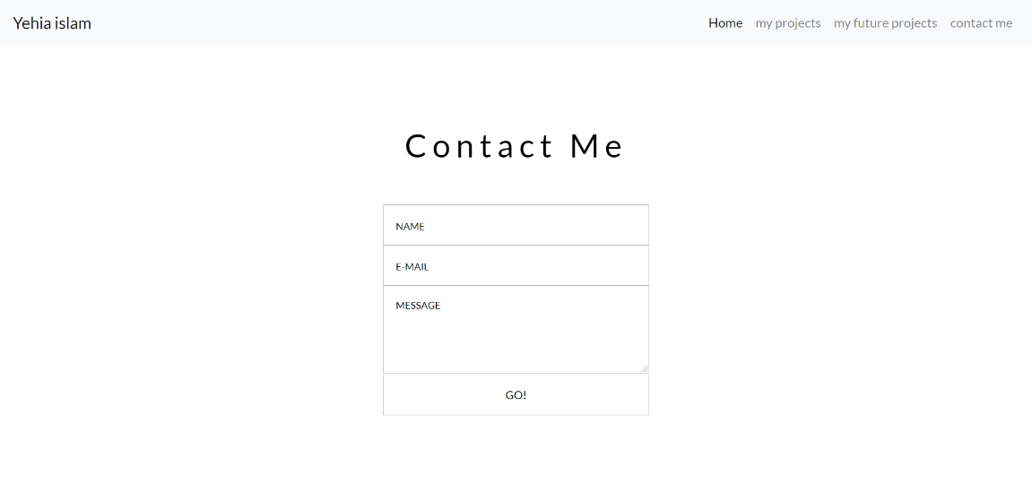It is a html form which I made it look better using CSS and this uses JavaScript and STMP server so any mailing website doesn’t think that this is a spam and after the 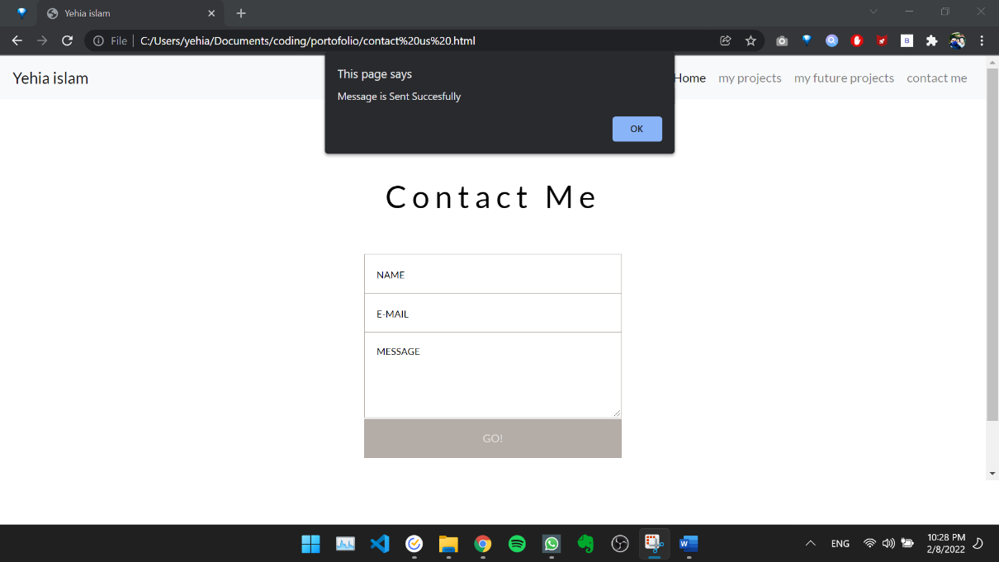message is sent a pop-up shows saying the message is sent successfully:

Secondly:

By dragging your mouse over any of these inputs and button (Go) the color will change:

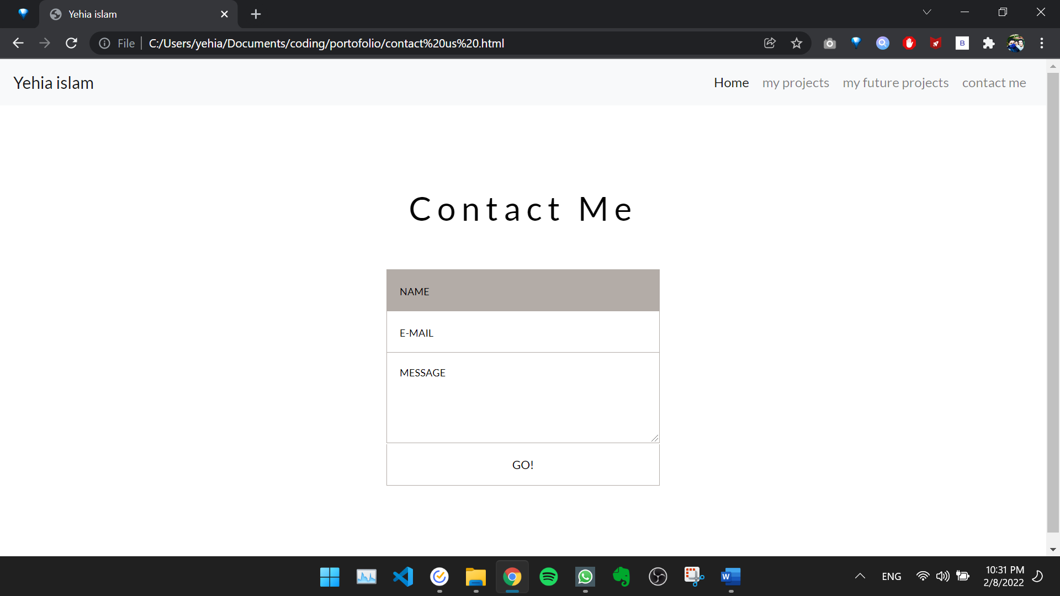

Thirdly :

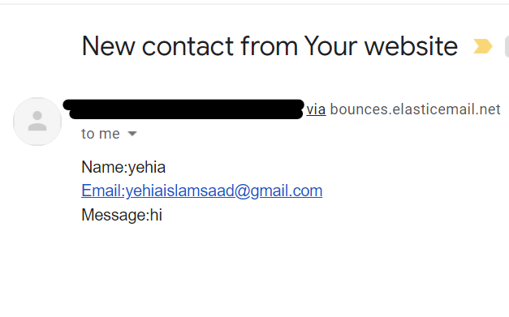The message when sent it comes to my email like that :

Blacked because I don’t want spamming